**LAB # 03**

**Task 01: Character Classification**

Write a C++ program that checks whether a given character is a vowel, consonant, or a digit. The program should prompt the user to enter a character and then display a message indicating the classification.

**Code:**

#include<iostream>

using namespace std;

int main(){

    char a;

    cout << "Enetr any character: ";

    cin >> a;

    if(a=='a' || a=='A' || a=='e' || a=='E' || a=='i' || a=='I' || a=='o' || a=='O' || a=='u' || a=='U'){

        cout <<"\'"<<a<<"\' is a vowel."<<endl;

    }

    else if(a>='0' && a<='9'){

        cout <<"\'"<<a<<"\' is a digit."<<endl;

    }

    else{

        cout <<"\'"<<a<<"\' is consonent."<<endl;

    }

}

**Output 1:**

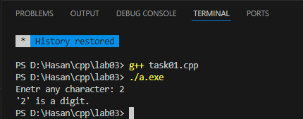

**Output 2:**

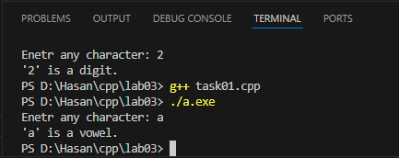

**Task 02: Shopping Cart**

You are developing an online shopping application for a retail store. The store wants to offer discounts to customers based on their total purchase amount. If the total purchase amount exceeds 15000 Rupees, a 10% discount will be applied to the customer's order.

Write a C++ program that prompts the user to enter the total purchase amount. Based on the entered amount, apply the appropriate discount using if-else statements and display the discounted amount to the customer.

**Code:**

#include<iostream>

using namespace std;

int main(){

    int ta = 0; //ta -> total amount

    float fa = 0.00; //fa -> final amount

    cout << "Enter the total amount of your purchased items: ";

    cin >> ta;

    if(ta>15000){

        cout << "Congragulations! you are getting a 10% discount."<<endl;

        fa = ta*0.9; //if getting 10% discount, means he's 90% amount

        cout << "Your discounted amount is: "<<fa<<endl;

    }

    else{

        fa = ta;

        cout << "Your total amount is: "<<fa<<endl;

    }

}

**Output:**

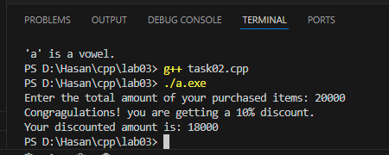

**Task 03: Age Analysis**

Assume that three friends are planning to do zip line adventure. Where age will be evaluated first to send the younger one first. Write a C++ program where compare age of 3 friends. Find the youngest one from all three.

**Code:**

#include<iostream>

using namespace std;

int main(){

    int age_fr1 = 0, age_fr2 = 0, age_fr3 = 0;

    cout << "Enter age of 1st friend: ";

    cin >> age_fr1;

    cout << "Enter age of 2nd friend: ";

    cin >> age_fr2;

    cout << "Enter age of 3rd friend: ";

    cin >> age_fr3;

    if(age_fr1<age_fr2 && age_fr1<age_fr3){

        cout << "1st friend is youngest, with age of "<<age_fr1<<" years."<<endl;

    }

    else if(age_fr2<age_fr1 && age_fr2<age_fr3){

        cout << "2nd friend is youngest, with age of "<<age_fr2<<" years."<<endl;

    }

    else{

        cout << "3rd friend is youngest, with age of "<<age_fr3<<" years."<<endl;

    }

}

**Output:**

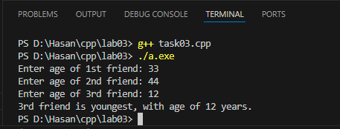

**Task 04: Medical Diagnosis System**

Write a C++ program that takes the user's input for body temperature and uses if-else statements to determine and display a basic medical diagnosis such as "Hypothermia," "Normal Body Temperature," "Low-Grade Fever," or "High Fever" based on different temperature ranges. Students can run the program with various temperature inputs to observe the different diagnoses.

|  |  |
| --- | --- |
| Temp less than 36.5 | Hypothermia |
| Temp in between 36.5 and 37.5 | Normal Body Temperature |
| Temp in between 37.6 and 38.5 | Low grade Fever |
| More than 38.5 | High Fever |

**Code:**

#include<iostream>

using namespace std;

int main(){

    float temp = 0.00;

    cout << "Enter your body temperature: ";

    cin >> temp;

    if(temp<36.5){

        cout << "You are diagnosed with Hypothemia."<<endl;

    }

    else if(temp>=36.5 && temp<=37.5){

        cout << "You temperature is Normal."<<endl;

    }

    else if(temp>=37.6 && temp<=38.5){

        cout << "You are diagnosed with Low Grade Fever."<<endl;

    }

    else{

        cout << "You are diagnosed with High Fever."<<endl;

    }

}

**Output:**

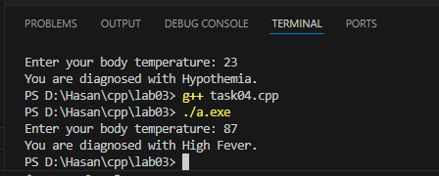

**Task 05:**

Imagine you are developing a program for a small business that sells handmade crafts. The owner recently bought a beautiful vase at a cost price (CPrice) and is trying to sell it at a selling price (SPrice). Your task is to create a program that will help the owner determine whether they made a profit, or incurred a loss.

Task Requirements:

1. Prompt the user to enter the Cost Price (CPrice) of the vase.
2. Prompt the user to enter the Selling Price (SPrice) of the vase.

**Profit Calculation:**

Profit = SPrice – Cprice

1. Print a message displaying the profit amount to the user.

**Loss Calculation:**

Loss = CPrice – Sprice

1. Print a message displaying the loss amount to the user.
2. If CPrice is equal to SPrice, output a message indicating that there is no profit or loss.

**Code:**

#include<iostream>

using namespace std;

int main(){

    int cp = 0, sp = 0; // cp -> cost price & sp -> selling proce

    cout << "Enter the cost price of vase: ";

    cin >> cp;

    cout << "Enter the selling price of vase: ";

    cin >> sp;

    if(sp>cp){

        int profit = 0;

        profit = sp-cp;

        cout << "You have made a profit of "<<profit<<" rupees."<<endl;

    }

    else if(cp>sp){

        int loss = 0;

        loss = cp-sp;

        cout << "You have made a loss of "<<loss<<" rupees."<<endl;

    }

    else{

        cout << "Selling price is same as cost price."<<endl;

    }

}

**Output 1:**

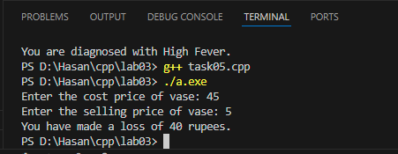

**Output 2:**

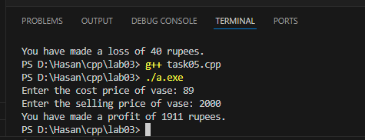

**Task 06:**

Write a C++ program that takes a digit (0-9) as input from the user and print its spelling using a switch statement.

**Code:**

#include<iostream>

using namespace std;

int main(){

    int dig = 0;

    cout << "Enter any digit between 0 & 9: ";

    cin >> dig;

    switch(dig){

        case 0:

        cout << "Its spelling is \'Zero\'"<<endl;

        break;

        case 1:

        cout << "Its spelling is \'One\'"<<endl;

        break;

        case 2:

        cout << "Its spelling is \'Two\'"<<endl;

        break;

        case 3:

        cout << "Its spelling is \'Three\'"<<endl;

        break;

        case 4:

        cout << "Its spelling is \'Four\'"<<endl;

        break;

        case 5:

        cout << "Its spelling is \'Five\'"<<endl;

        break;

        case 6:

        cout << "Its spelling is \'Six\'"<<endl;

        break;

        case 7:

        cout << "Its spelling is \'Seven\'"<<endl;

        break;

        case 8:

        cout << "Its spelling is \'Eight\'"<<endl;

        break;

        case 9:

        cout << "Its spelling is \'Nine\'"<<endl;

        break;

        default:

        cout << "Invalid input!"<<endl;

        break;

    }

}

**Output 1:**

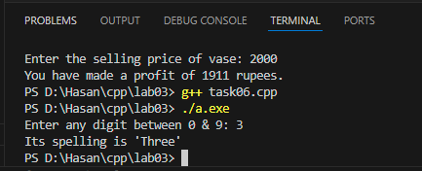

**Output 2:**

